**Roll No:20AD051 Assignment: 1 Date:04/06/2023**

**Question 1:**

**Query for creating table**:

create table BooksDB(

Book_Title varchar(50),

Author varchar(30),

Genre varchar(50),

Publication_year int,

Price int

);

1. **Reterive all books:**

select*from BooksDB;

**Output:**

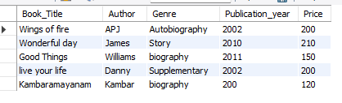

1. **Query for printing books Title:**

select Book_Title from BooksDB;

**Output:**

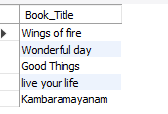

1. **Query for Updating price in a Table:**

update BooksDB set Price=300 where Book_Title="Wings of fire";

select*from BooksDB;

**Output:**

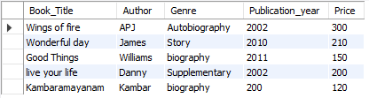

1. **Query for Deleting Table:**

delete from BooksDB where Book_Title="Good Things";

select*from BooksDB;

**Output:**

